Buried in
Treasures
A Group Work Program for People with Hoarding Behaviour/Clutter
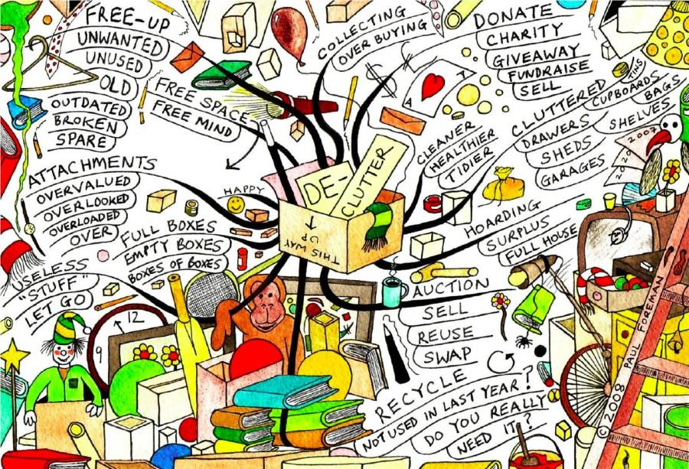

This group offers a judgement free environment for people ready to make a change in their life.

- Would you like to learn tips on how to de-clutter?
- Join us for this group for people who are ready to live a life less cluttered!
- Each week we’ll either introduce a new skill from the book, Buried in Treasures, or discuss a topic that is important and interesting to the group. This is a 15 week course.
- We’ll also check in with our individual progress, challenges, successes, and goals.

Every Monday 1 - 3pm

Dates: 16 March to 20th July (not including Public Holidays)

We will meet at Salvation army building 325 Mitcham road Mitcham 3132

Cost: $20.00 for the workbook Referrals close: 6th March 2020

For referrals or more information in the Whitehorse, Monash, Manningham and Boroondara areas please contact the facilitators:
Jenny Parbery from Mind on 043 6287 167 Jenny.Parbery@mindaustralia.org.au
Millie Gaica-Marcetic from Salvation Army on 0438 098 923 / 03 989 07144 millie.gaica-marcetic@aus.salvationarmy.org

